**GUESS THE ANIMAL**

**Screen: Home Screen**:

* List of Existing Animals displayed as Lion, Dog, Bird from the Administrator perspective to maintain it as desired

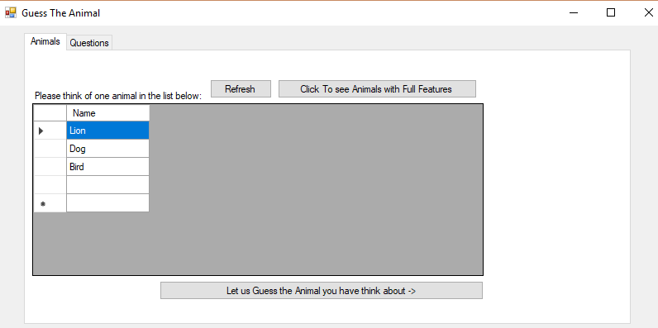

**Screen: Full Featured Animals**

* Button : Click to See Animals with Full Features
* Click this button to see all the features of the Animal
* Below list displayed with all features

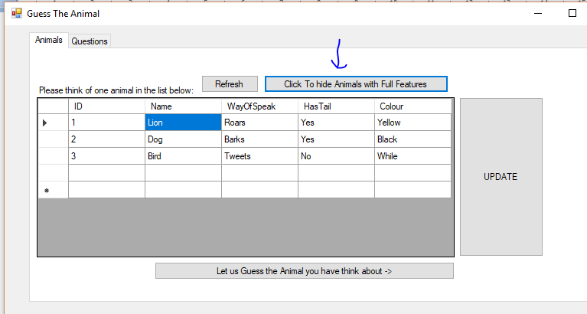

**Screen: Hide Animals Full Features**

* Button: Click to **HIDE** Animals with full features
* Clicking this button will hide the ALL FEATURES and display only the essential part of the list

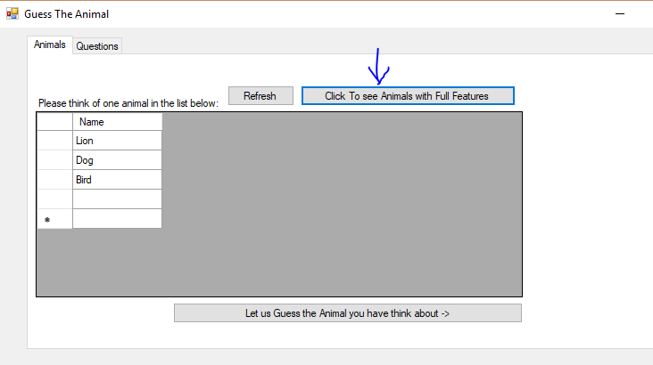

**Screen: Edit Animals**

* New Animals can be added
* Existing Animals can be Updated/Deleted
* by simply editing the GRID cells and click UPDATE

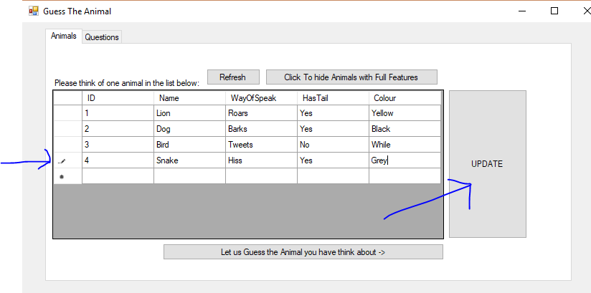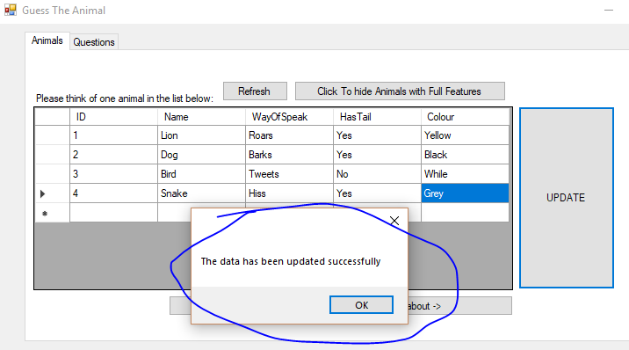

**Screen: DELETE Animals**

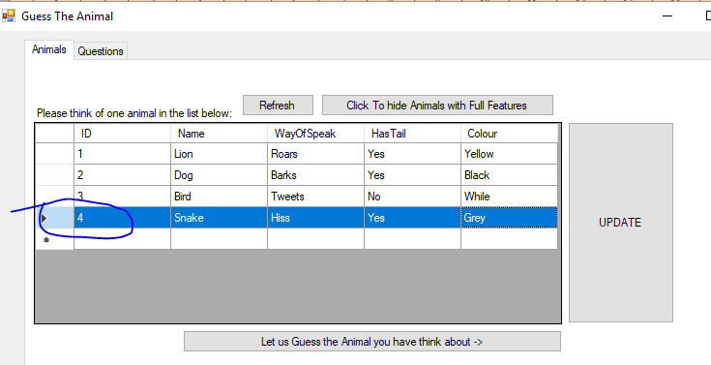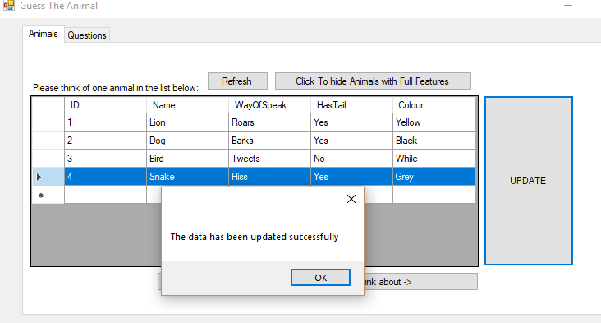

**Screen: GUESS THE ANIMAL**

* Click upon the button “Let us Guess the Animal you have think about”
* It takes the user to next screen

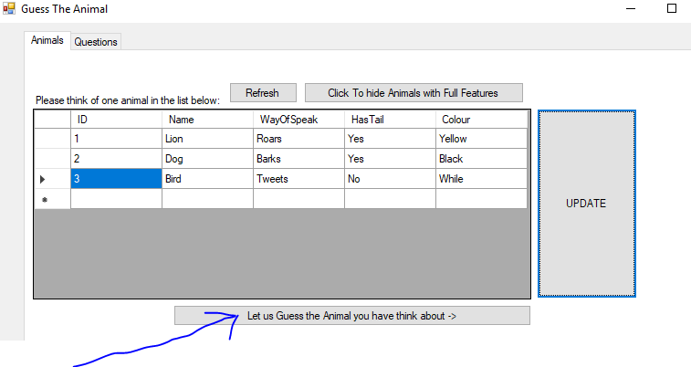

**Screen: Selection Criteria**

* Answer the asked **Series of Questions**
* Based upon the Selected Answers from the dropdowns, and the matches from the Database, Answer is displayed in the right panel
* Example: Choosing Way of Speaking + Has Tail + Colour of Animal fetches LION from the Database 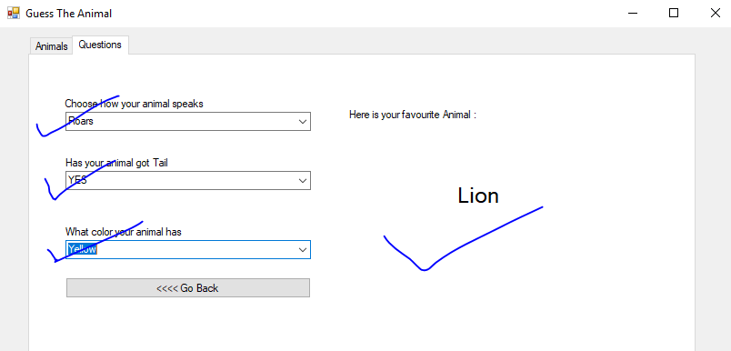

In Case the selection criteria do not meet any match from database, **NO MATCH FOUND** message is displayed

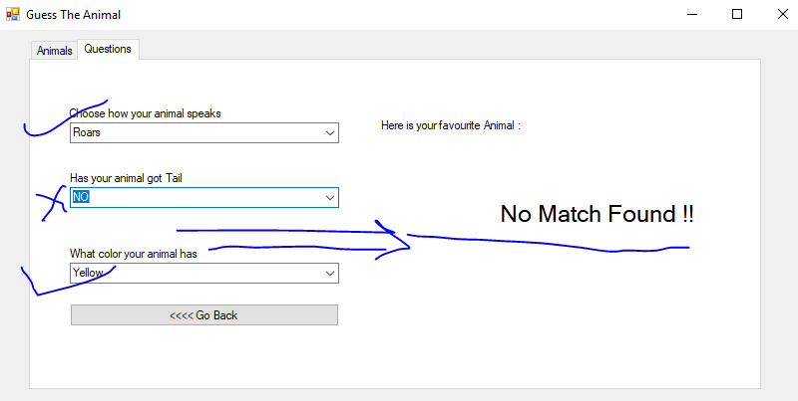

**END**

**Gaurav Verma**